The Importance of Organizational Behavior

This chapter I learned about the importance of organizational behavior (OB) and how it affects all of the employees from CEO to intern when concerning productivity and enjoyment of the workplace. Prior to this course, I wasn’t really sure what organizational behavior was, or how it plays an integral role in the culture of a workplace. Nonetheless, I’ve learned how organizational behavior affects how well an organization functions as well as how profitable they can be. A crucial role of organizational behavior is management, management helps define goals for an organizational department and helps them fulfill those goals they’ve set. The three main responsibilities of management are to recruit, train, and maintain the skill-level of their employees.

**Creating a Healthy Work Environment**

Along with those responsibilities, another key objective of a manger is to oversee a healthy workplace environment for their employees. While this may seem like a trivial responsibility, a healthy workplace environment is crucial to the overall psychological state of an employee.

A dysfunctional workplace environment has been shown to cause unproductivity as well as lead to many internal conflicts at an organization. This is why it is important that a manager has the technical skills to do their job, as well as the interpersonal skills to help lower the turnover of quality employees, maintain positive outcomes for the organization, and achieve overall higher performance out of their employees.

**Aspects of a High Peforming Team**

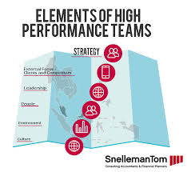While ensuring high performance out of your employees is crucial in organizational behavior, it is also important to change the culture of the company to a culture that seeks to improve from its experiences every day. While creating this culture is difficult at first. It has shown that a culture of challenge and respect leads to a more productive and mistake free working environment. Changing the culture of a workplace is difficult, however, due to the many types of people at an organization. It is important to empower your employees to seek challenges, but not to the point where every thought is challenged by every employee. This is where the difference of good managers and great managers comes in to play.

**The Importance of Great Management**

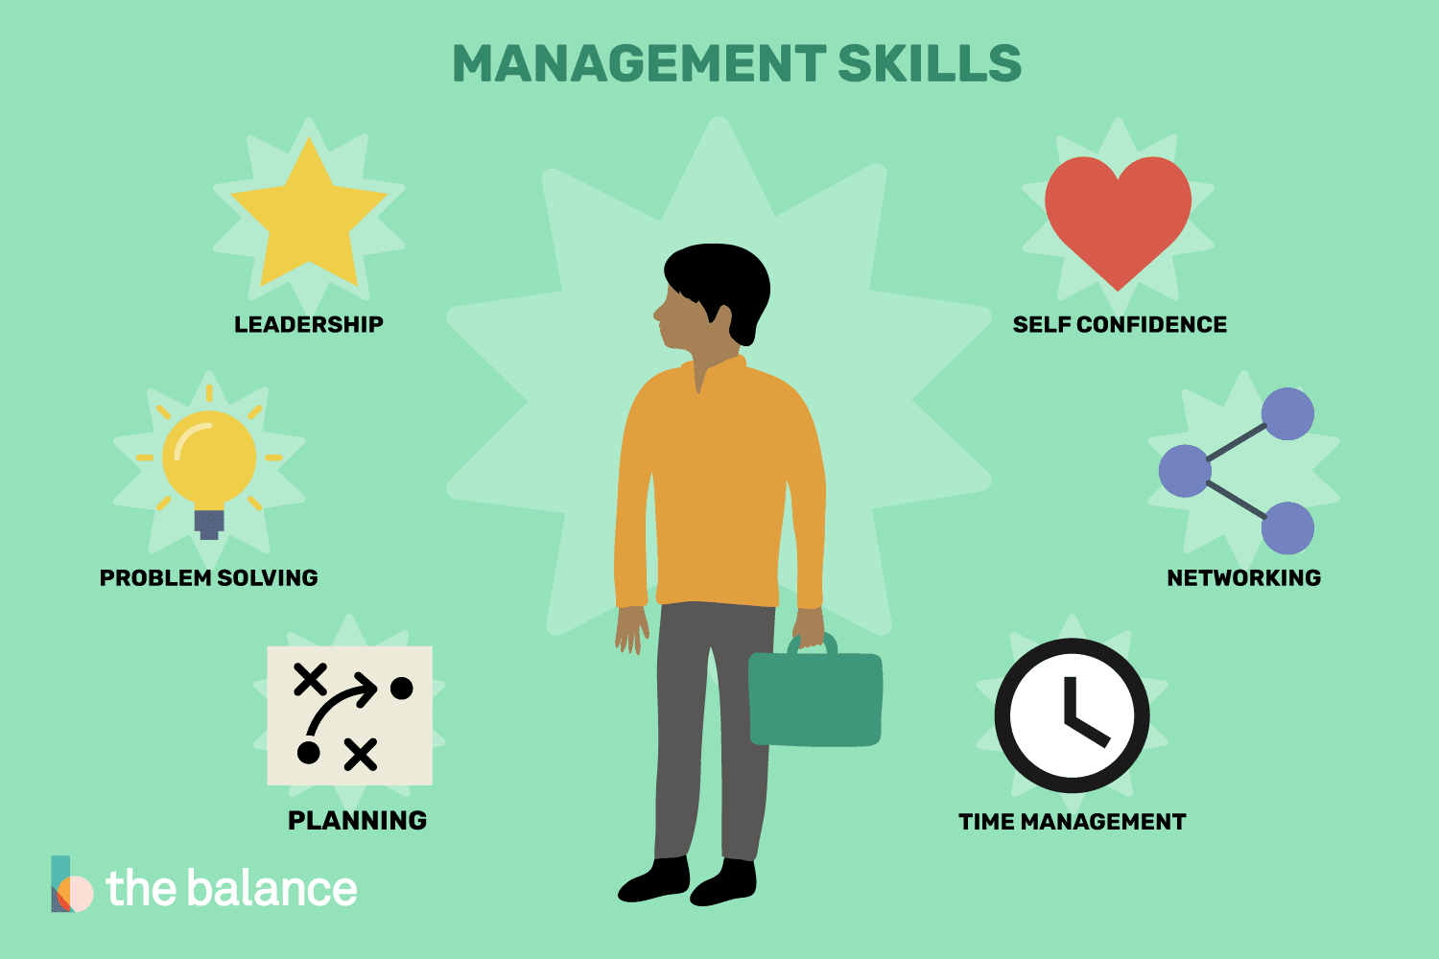The success of every business relies heavily on its management, and the key to great management is communication. Communication is important in every aspect of management. For example, employees need to know what your expectations are for them, they need to understand what you want from that specific project in order to do their job well. Good organizational behavior dictates that a manager should be as clear and concise as possible when communicating goals with their employees, it is also important that a great manager makes themselves available for their employees in case they have any questions regarding the project they have been tasked with. Allowing this double feedback loop is crucial in terms of organizational behavior. If you are not clear with your expectations with the project, your team may feel lost or as if this project isn’t worth doing. At the same time, if you don’t allow them to ask you for feedback or any questions regarding the project, then there will more than likely be a few errors with the project that you have assigned them.

Being a great manager requires an extensive knowledge of organizational behavior as well as managing different types of individuals. This is done through good communication skills, understanding different personality types, and creating a culture of empowerment and comfort within your organization.